**Practical Observation and some Cases found in Project**

1. **Nifty 50**

**Day 1:**

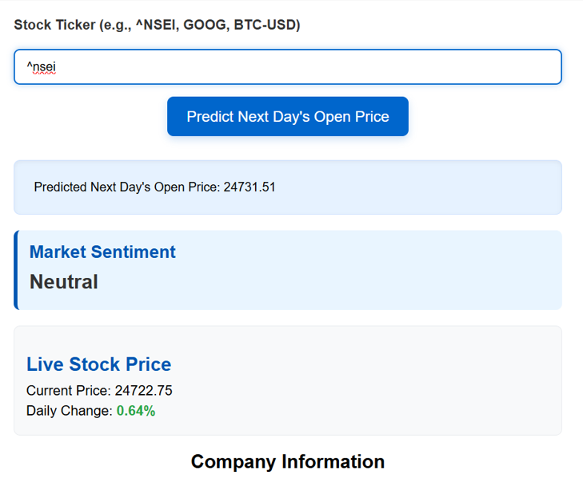

In day 1 predicted price is higher than previous day closing price. And Daily change is positive that means the stock price get higher from its previous day closing price so the prediction by the software is correct.

**Day 2 (Part 1):**

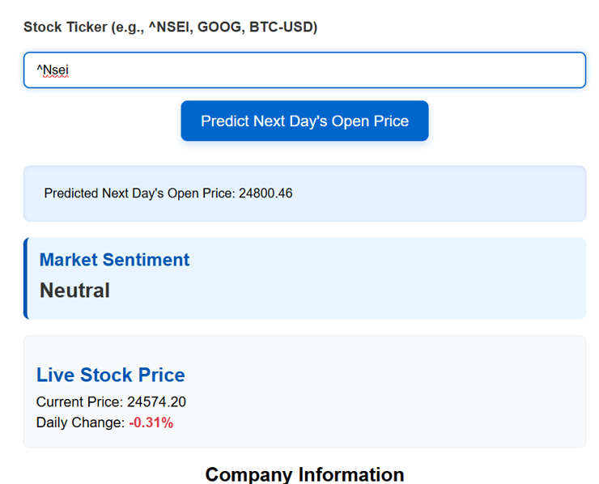

In day 2 predicted price is much higher than previous day closing price but after market open the daily change is negative that means the stock price get lower from its previous day closing price so at starting 3 hours the prediction gets wrong but.

**Day 2 (Part 1):**

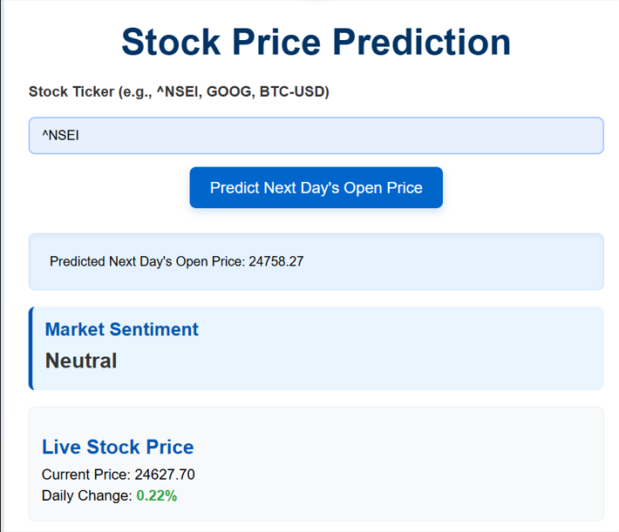

But after starting 3 hours the stock gets start to recover and closed up in to the profitable state which is a rare site to see and the prediction get correct in the end. But this is a very risky trade session.

**Day 3:**

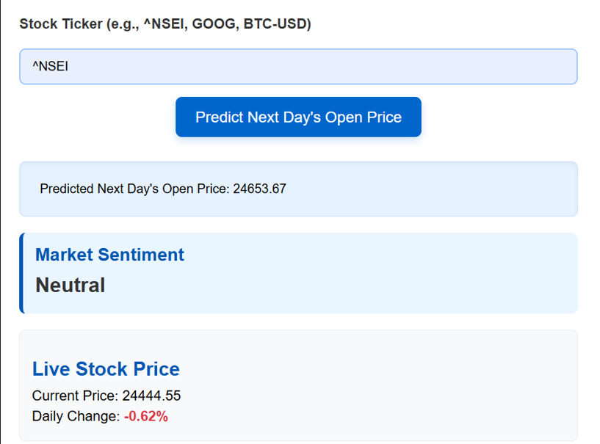

In day 3 predicted price is higher than previous day closing price but the difference between the previous day closing and predicted price is very low. so this is a pressure after market open the daily change is negative that means the stock price get lower from its previous day closing price which is a very high possibility in this type of market.

1. **Google:**

**Day 1:**

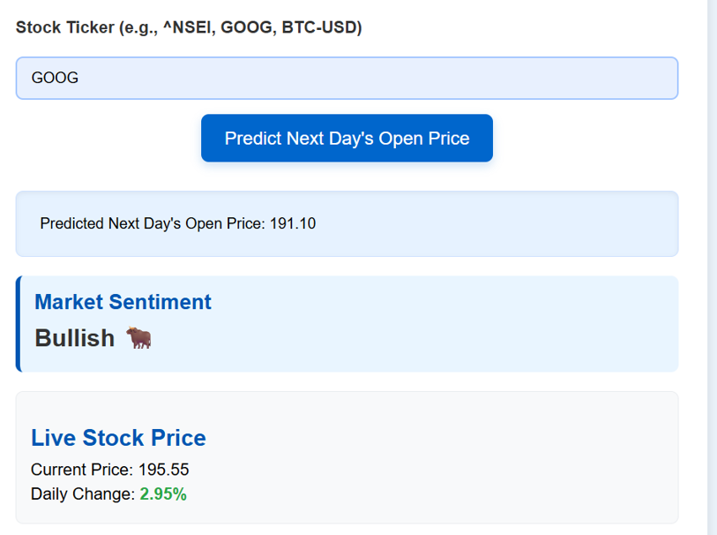

In day 1 predicted price is higher than previous day closing price and but difference between them is approx. negligible. And Daily change is positive that means the stock price get higher from its previous day closing price so the prediction by the software is correct. But in this case the we cannot predict the price only by trend analysis. We use market sentiment which is bullish so, we have chances to go higher.

**Day 2:**



This is the most interesting case of this prediction model. In day 2 predicted price is lower than previous day closing. And Daily change is negative that means the stock price get lower from its previous day closing price. But the market sentiment is Bullish so, if we considered all these than it has two cases in bullish side dominates so the price goes up but if trend side dominates so market goes down. In this the trend side dominates so price goes down. This is most complicated case, a model can predict this than it has 100% accuracy in prediction.

**Day 3:**

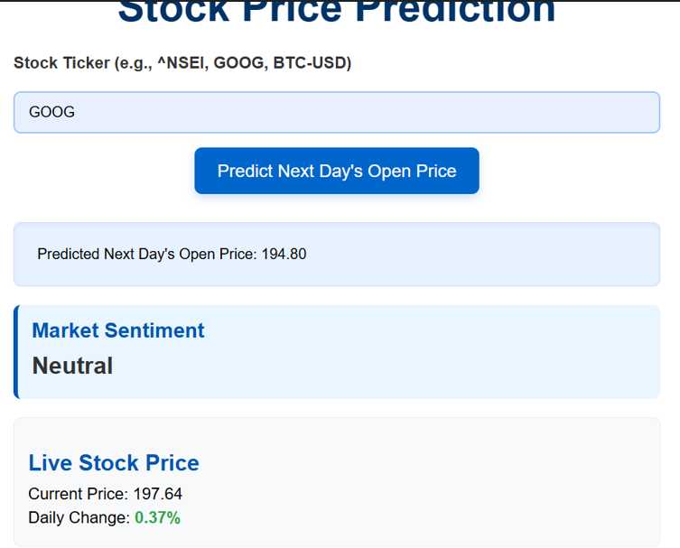

In day 3 predicted price is lower than previous day closing price. but difference between them is very low so there are the chances of rally that means the stock have chances to go up. And Daily change is positive that means the stock price get higher from its previous day closing price. So, in this case the stock gets higher which works as the break down point in it rally to set a base for its next upcoming increases.

**3.DOGE-USD:**

**Day 1:**

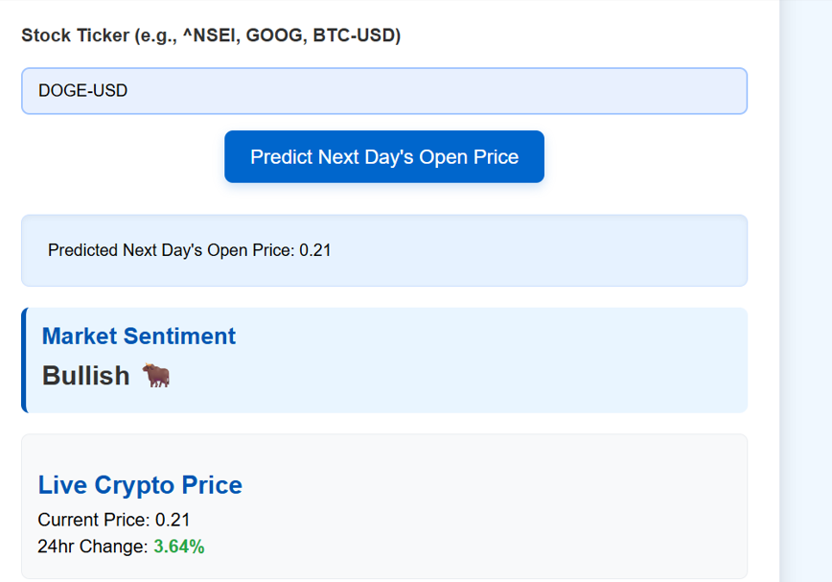

In day 1 predicted price is higher than previous day closing price and the market sentiment is also bullish. And Daily change is positive that means the stock price get higher from its previous day closing price. So, we say that the prediction is correct.

**Day 2:**

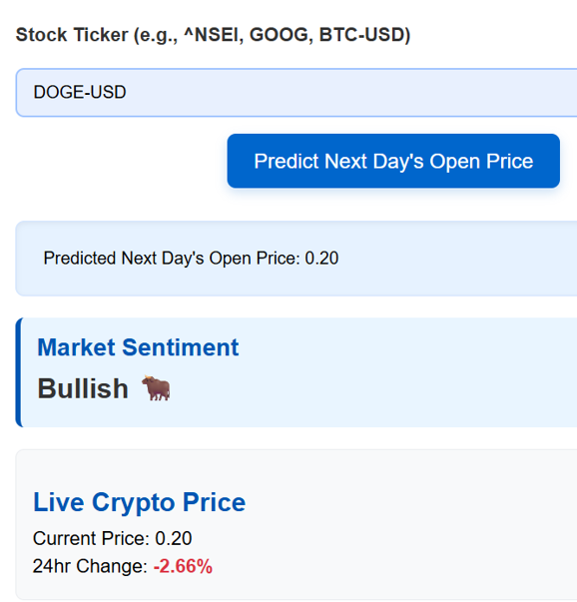

In day 2 predicted price is lower than previous day closing price but market sentiment is bullish. So, in this case the predicted price is dominated. And Daily change is negative that means the stock price get lower from its previous day closing price.

**Day 3:**



In day 3 predicted price is higher than previous day closing price and the market sentiment is also bullish. So, in this case the bullish sentiment is dominated heavily. And Daily change is positive that means the stock price get higher from its previous day closing price.

**NOTE:** This data is observation of 7 days and we mention only some interesting and rare cases in this observation file.